Experiment

Design an automated night lamp

Circuit diagram:

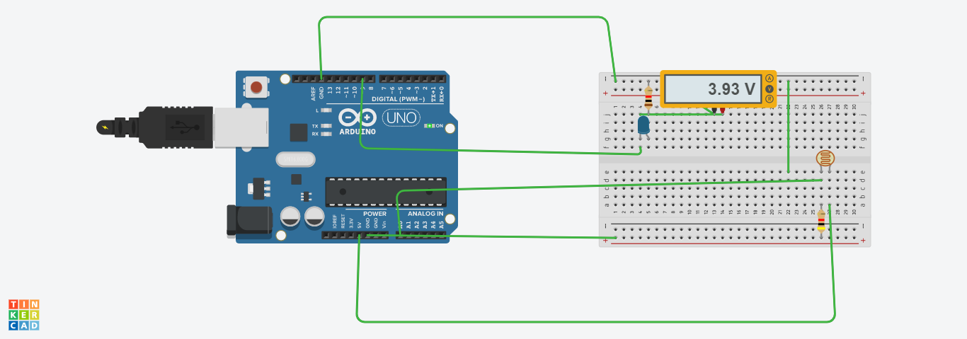

**Theory:**

# CONCEPT USED:

* **By using kirchoff’s voltage law**

&

* **By using kirchoff’s current law**
* **Photoradiation**
* **Use of LDR(Light Dependent resistor)**
* **Use of potentiometer**

# LEARNING AND OBSERVATIONS:

* **Connections in Breadboard and wiring.**
* **How to control arduino and its coding.**
* **Use of multimeter for continuity.**
* **Light sensor devices**

**OBSERVATION:**

* **Sense of brightness and darkness**
* **Relation between software and hardware.**
* **Varation of voltage**

# PROBLEMS & TROUBLESHOOTING:

* **To select the right port and type of arduino**
* **To check the loose connections**
* **To check the connections according to the codes**
* **To check the continuity of the circuit**
* **To check the flow of current in the circuit**
* **Errors in code**
* **Setting up right connections**
* **Display in proper order**
* **Pinmodes of devices**

# PRECAUTIONS:

* **Handle tools carefully**
* **Wear gloves**
* **Do not connect arduino till the circuit is complete**
* **Do not connect leds without a variable resistor**

# OUTCOMES:

* **Making of automated light devices**
* **By sensing light**
* **Proper use of Arduino and breadboard**

**Created By-**

**Name: RISHABH GUPTA**

**ROLL NO: 19BCS3792**

**Stream: CSE(BD1 B)**

**University: CHANDIGARH UNIVERSITY**